# HW1. Character-based Histogram

Carefully read this *entire document* before beginning your work

## Objectives

* learn Java syntax
* display to the terminal
* for loops
* static methods with parameters and returns
* overloaded methods

The voter participation data we will work with is stored in a Word document **Presidential Elections.docx** or you can find on <http://www.sos.wa.gov/elections/voter_participation.aspx>.

It’s expected that you hard code the bar data in the **main()** method, i.e., I expect to see the corresponding values typed into your program and passed to the functions as arguments. Outside of this, you should have no “magic numbers”; use values from the website instead.

## Constants Definition

For this program, gather no input from the user. Instead, define constants to hold key data, making it easy to change the values to test your program.

*Define at least these constants* to hold general histogram settings:

|  |  |  |
| --- | --- | --- |
| **Constant** | **Description** | **Sample** |
| Histogram title | Text that will appear centered (over a 80-character space) before the histogram is displayed. One blank line follows it. | "Presidential Elections" |
| Histogram characters | The character to be repeated to create the data bar | T, R, V |
| Scale | Use a scale for the chart to create bars in the appropriate size | 100,000 |
| Step | Use a step for the chart to create axis | 1,000,000 |

## 

## Output

The output of the program is a character-based **histogram** showing some barsof data taking from the website. Use at least 5 different years. The header should be in the center of the first line.

Don’t hardcode numbers, e.g., for the axis values. In other words, don’t have a print statement that prints a string literal “5000 10000 15000 …”; write a proper loop instead and use steps and scales. The same goes for tick marks.

You don’t need to make the number range flexible; see the top values in the file.

Also, you don’t need to guard against bad data. But you should test your program with values that are in the specified ranges that should work.

**Sample:**

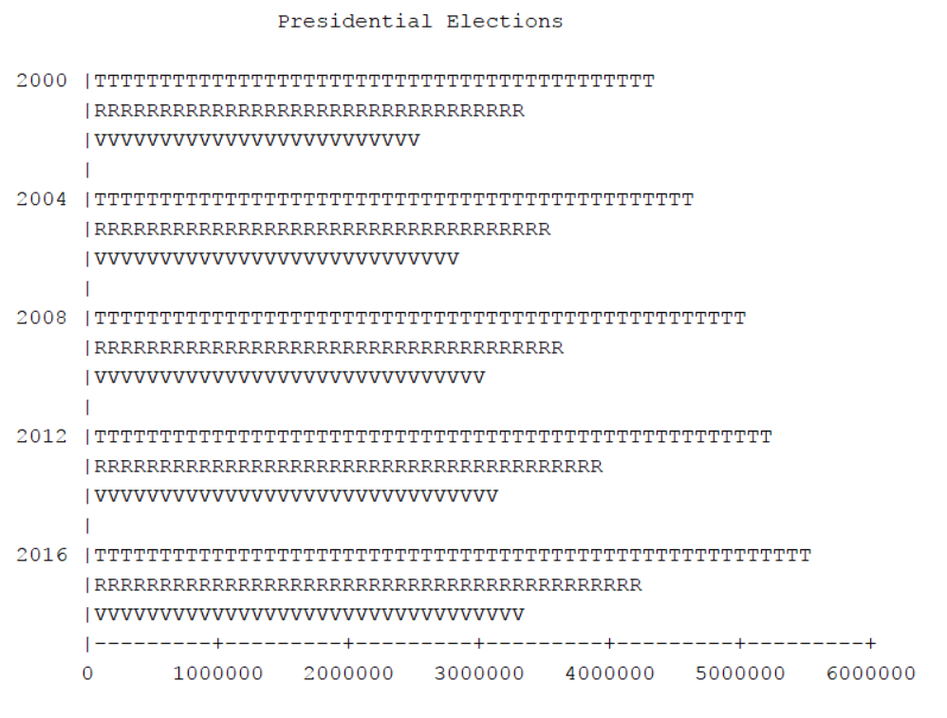

## Calculations

There are no special calculations. Do the ones you need to create the desired output in the **printHeader()** method. You may wish to use the String length method; this *one* is allowed.

Example:

String userName = "Any Name";

int userNameLen = userName.length();

## Code Implementation

Create a class called **Histogram**. Follow the provided Course Style Guide.

5.1 Hierarchy

Create the following static functions. Use this exact call hierarchy:

* **main()** should consist of a series of function calls and **nothing more**
* **printHeader()** should accept one parameter – the name of the chart
* **createBar()** will be an overloaded method
* the firsts variant should accept four parameters:
  + - * an integer specifying the bar title (the year)
      * an integer indicating the bar value
      * the character to be repeated to create the data bar
      * the scale
* the second variant accepts three parameters, the same as the first but excluding the year.
* **createAxis()** should accept one parameter – a step
* **emptyRow()** should accept no parameters

None of the functions should return any value

5.2 What You May Use

* Constants (at class level), using the recommended casing and word separator
* Variables (but not class-level ones)
* Assignment and calculations
* Definite loops
* Console output

5.3 What You May Not Use

* Indefinite loops (no while)
* Selection control structures (no if) unless you’re doing something way “above and beyond”
* Arrays, lists, or other data structures or objects we haven’t covered
* Libraries or methods we haven’t covered

## Submitting Your Work

Submit the **.jar** file from your homework or **zip** up the entire folder.

## Other Requirements

* Your design must use procedural decomposition.
* Use class constants where appropriate.
* The program must start with main().
* Your file must have a program comment at the top. This description, at a minimum, is one to two lines explaining what the program does.
* Include your name and date in the file comments.
* Each method must include a block comment that describes what the method does a description of parameters (if there are any) what is returned (if anything is returned)
* In addition to the block comments, also include algorithm comments, that help to explain your algorithms.
* Use good style, such as good variable and method names, class constants, appropriate indentation, etc.

## Grading

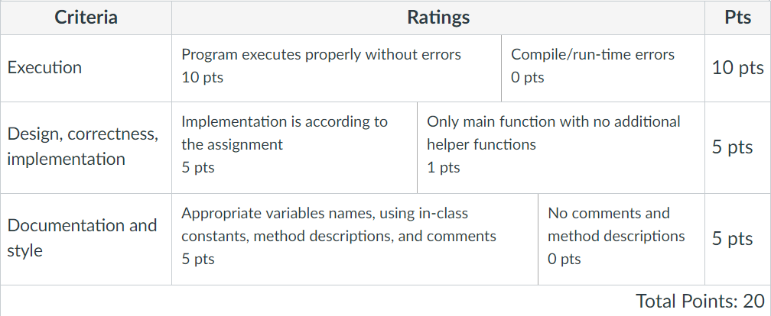

## Extra Credit (5 points)

Add to your project additional information

* Percentage of Voting Age Population Registered
* Percent of Voting Age Population Voting

Don’t copy this information from the site, you should calculate it and compare your result to the website. Create a new method that accepts parameters and print the result as follows:

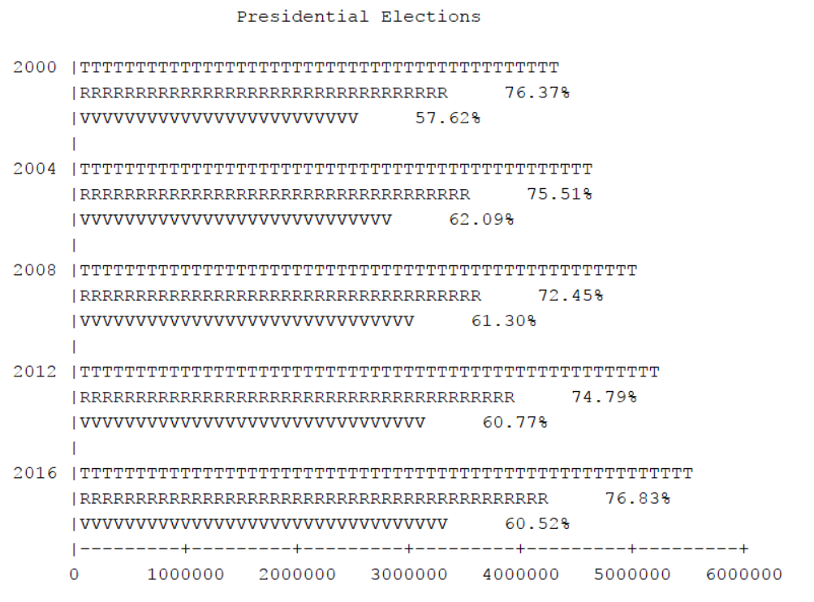

**Hint**. For the output variables of type double, you need to use **printf()** method.